SystmOnline User Guide

Access the main Systmonline screen,

- typing in to your browser ribbon https://systmonline.tpp-uk.com (not the search engine.)

- or by clicking on the app on your smartphone.
systmonline

- or use the link on our website http://www.rosegarthsurgery.co.uk Click on the Online Services tab & scroll down to the Click here to log in to online services link.

Using SystmonLine on a laptop or computer
On the log in screen you can either log in using existing details
You will initially be given a random password and when you log on for the first time, you will be prompted to change it to something more memorable.

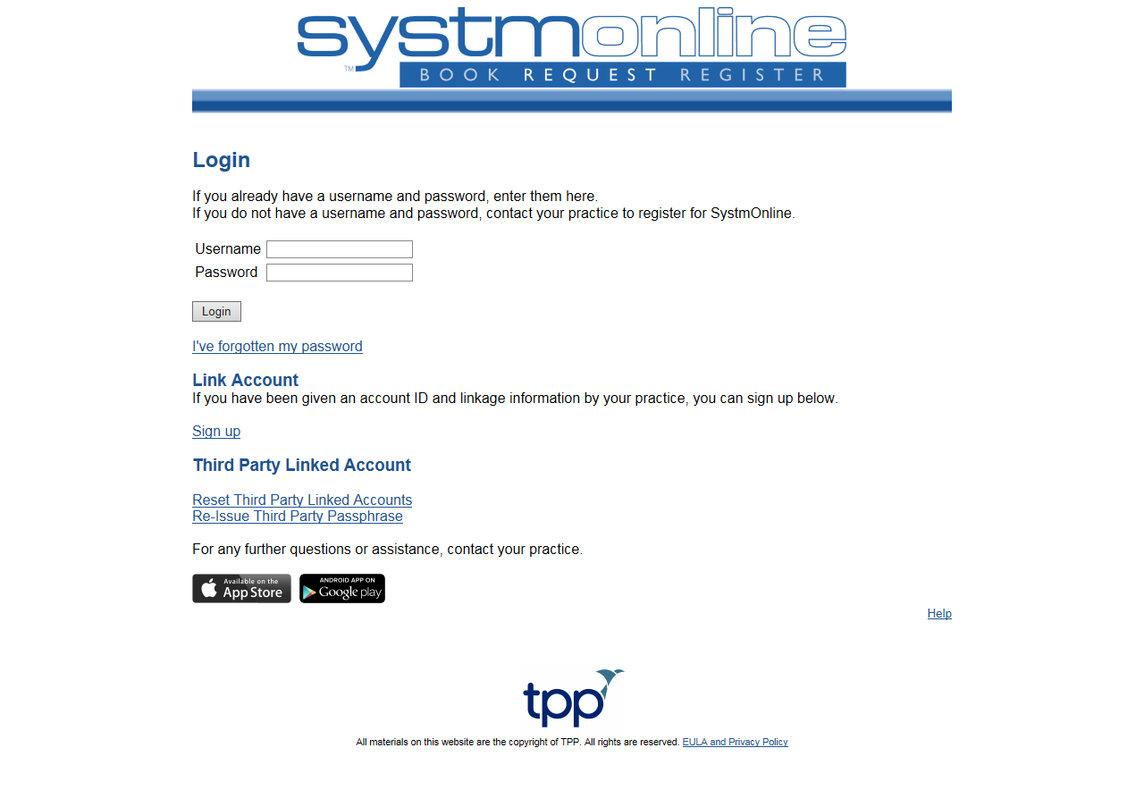
The Log In Screen

If you are not registered for this service, please contact any of our receptions at the surgery or download the form from our website.

If you have forgotten your password this can be reset by clicking the “forgotton password” link on the log in screen, or by contacting the surgery. You are best to use the forgotten password link as you will be required to come to the surgery with ID to collect a new password.

Please note - Usernames are usually in the format of FirstnameSurnameDDMMYY (DDMMYY being your date of birth). Passwords should contain at least 1 non-alphnumeric symbol, for example ! * £ % etc.

Once you log in you will come to the Home screen. You can get back here anytime by clicking the “Home” button on the Blue Toolbar at the top of the page.

Please DO NOT use the back button on your browser at any point as this may result in an error.

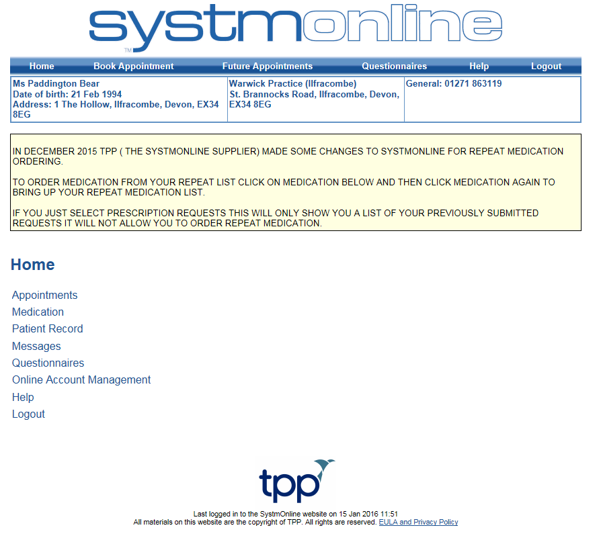
The Home Screen

Booking an appointment:
Select “Appointments” from the list on the home screen. On the appointments screen you can choose to book an appointment, view a list of your future booked appointments, or a list of your past appointments. You can also skip straight to the booking screen by clicking on “Book Appointment” on the blue Navigation bar at the top of the screen.
Select “Book Appointment”. This will take you into the available sessions screen. You can select different dates from the pull down list where available; however we only allow patients to book up to 2 weeks in advance. If no appointments appear then there are no available pre-bookable appointments.

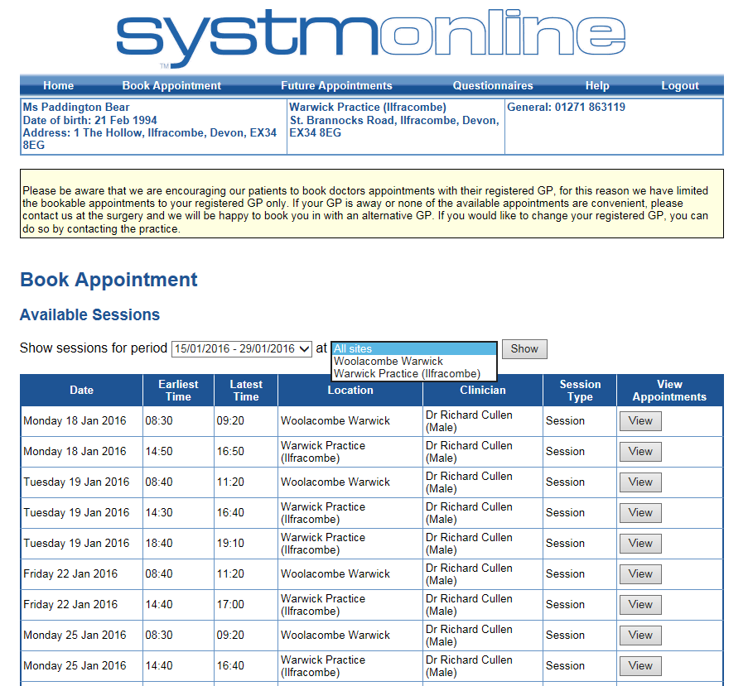
The Available Sessions Screen
The list will show the available sessions for your GP on specific dates. You will need to click on the “View” button next to the session to take you into the booking screen to see the individual appointments available.

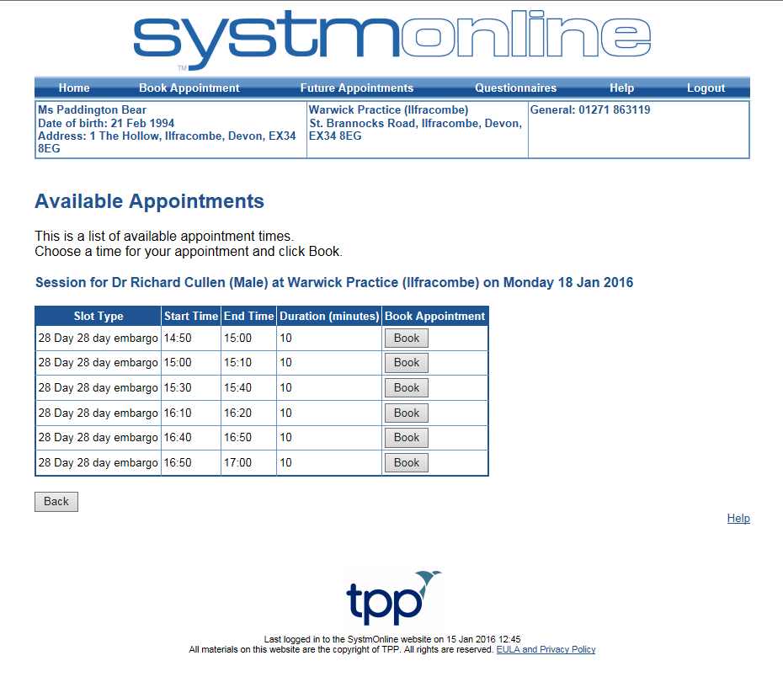
The Booking Screen
To book an appointment click the “Book” button next to your preferred appointment time.
On the following screen, please check the appointment details are correct, and then click “Book Appointment” to book it.
You will then be taken to a confirmation screen where you can print your appointment details or return to the appointment booking screen. You can also select one of the buttons on the top blue navigation bar i.e. “Log Out”.

Ordering Repeat Medication
To order your repeat Medication, click on the “Medication” link on the home page to take you into the medications screen.
The Medications Screen
This will give you another set of options. Clicking on “Medication” again will take you into the medication ordering screen where you can order your medication. The “Prescription Requests” link will take you to a list of previously requested medication, and the “Change Pharmacy” will allow you to change which pharmacy your prescription is automatically sent to if you are signed up for Electronic Prescription Service (EPS) – please note you will not be able to use this function unless you have signed up for this service. Further details on Electronic prescribing and a form are available at Reception or your chosen Pharmacy.
Click on the “Medication” link.
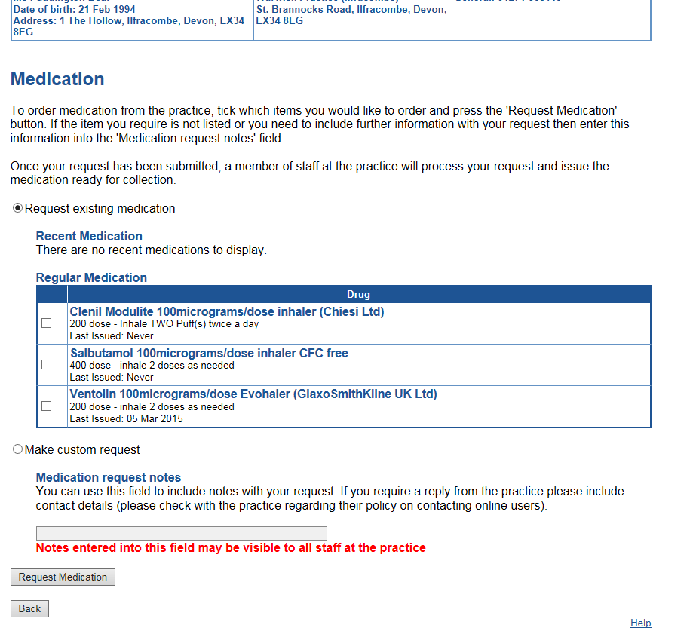
The Medication Ordering Screen
On the Medication ordering screen you will be given a list of medication which is on repeat. If you do not see anything on the list, it could be that it is not due for issue, or that it has not been put on repeat, in which case you will need to speak with the practice who will be able to advise you.
You can click the box next to all the medication you would like to request and you also have the option to free text into the notes box with any other requests, for example, to send the prescription somewhere different this time, or if you are going away and wish to order anything early. You can also add text notes on the following confirmation screen.
Click the “Request Medication” button when you are finish. On the following screen, check the details of the prescriptions you are ordering and add any notes, then click “Request Medication” again.
You will then be taken to a confirmation screen where you can print the page for your records, and return to the medications screen. You can also use the navigation buttons at the top of the screen to return to the home page or log off etc.

Patients Record
This section allows patients to select whether they wish to view their basic medical record online (Summary Care Record – SCR). You can view your SCR which includes your allergies and any past or current medications. On the Patient Record Screen you also have an option to view your childhood immunisations and any test results if your practice has this option enabled.
Questionnaires
This section contains any practice questionnaires which you can fill out. Please take a look at the available questionnaires; we would be very grateful if you could take the time to fill these out.

Online Account Management
You can access the account management screen by clicking the link on the home page. From here you can:
- Send a change of details message to the practice if you have changed address/contact details etc.
- Change your SystmOnline Password
- Link your account to another person’s SystmOnline account, for example if ordering prescriptions for a friend or relative on a regular basis. Please note we will need confirmation from all parties to link accounts.
- Manage Online Services – Remove or request access to certain parts of the site.
- Reset you SystmOnline access (This will close your online account and you will need to contact the practice to regain access).
- View and manage linked account access
- View the help files for SystmOnline
- Log out.
Help
This section contains further information on SystmOnline and help to answer any questions you may have.
Logout
Clicking ‘Logout’ will log you out of SystmOnline.

